LABORATORY RECORD
DSA1606 – Knowledge Engineering and Data Science
Lab 2

Name | Yarrapureddy Lakshmi Reddy
Register No. | 192324077
Department | AIDS
Course Code | DSA1606
Course Name | Knowledge Engineering and Data Science
Course Faculty | Dr. Sarasu Raghupathy

Contents
Q. No. | Title
1 | Grade Distribution – Pie Chart and Bar Chart
2 | Grade Analysis using a CSV File and pandas
3 | Knowledge-Driven Object Identification
4 | Car Number Plate Recognition using OCR and an Expert System

Question 1: Grade Distribution – Pie Chart and Bar Chart

Aim
To store the grade-wise results of 40 students, draw a pie chart and a bar chart for the distribution, and find the grades with the maximum and minimum number of students and the combined percentage of grades A and S.

Algorithm
- Start and import matplotlib.pyplot.
- Store the grades (F, E, D, C, B, A, S) in a list and the number of students for each grade in another list.
- Calculate the total number of students and the percentage for each grade.
- Draw a pie chart with grade labels, percentage values, a title and a legend.
- Draw a bar chart of the number of students per grade with the X-axis labelled “Grades”, the Y-axis labelled “Number of Students”, a title and a legend.
- Write the exact count above each bar.
- Find the maximum and minimum number of students and display the corresponding grades.
- Add the students with grades A and S, calculate their percentage of the total and display it.
- Stop.

Code
import matplotlib.pyplot as plt

grades = ["F", "E", "D", "C", "B", "A", "S"]
students = [3, 4, 5, 8, 9, 7, 4]
total = sum(students)
percent = [s / total * 100 for s in students]

# Pie chart
plt.figure(figsize=(7, 7))
plt.pie(students, labels=grades, autopct="%1.1f%%", startangle=90)
plt.title("Percentage Distribution of Students by Grade")
plt.legend(grades, title="Grades", loc="center left", bbox_to_anchor=(1, 0.5))
plt.tight_layout()
plt.show()

# Bar chart
plt.figure(figsize=(8, 5))
bars = plt.bar(grades, students, color="skyblue", label="Number of Students")
for b in bars:
plt.text(b.get_x() + b.get_width() / 2, b.get_height() + 0.1,
str(int(b.get_height())), ha="center", va="bottom")
plt.xlabel("Grades")
plt.ylabel("Number of Students")
plt.title("Number of Students per Grade")
plt.legend()
plt.tight_layout()
plt.show()

# Max / Min
mx, mn = max(students), min(students)
print("Grade with maximum students:", grades[students.index(mx)], "(", mx, ")")
print("Grade with minimum students:", grades[students.index(mn)], "(", mn, ")")

# A + S percentage
a_s = students[grades.index("A")] + students[grades.index("S")]
print(f"Percentage of students with grades A and S combined: {a_s / total * 100:.2f}%")

Output
Text output
Grade with maximum students: B ( 9 )
Grade with minimum students: F ( 3 )
Percentage of students with grades A and S combined: 27.50%

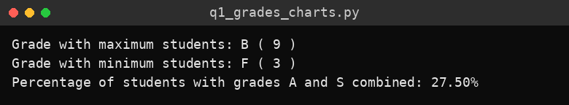
Console output
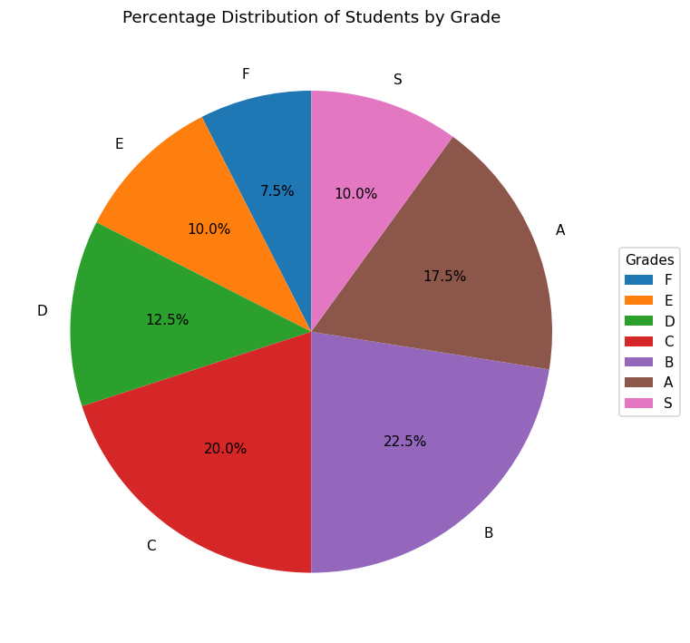
Figure 1: Pie chart – percentage distribution of students by grade
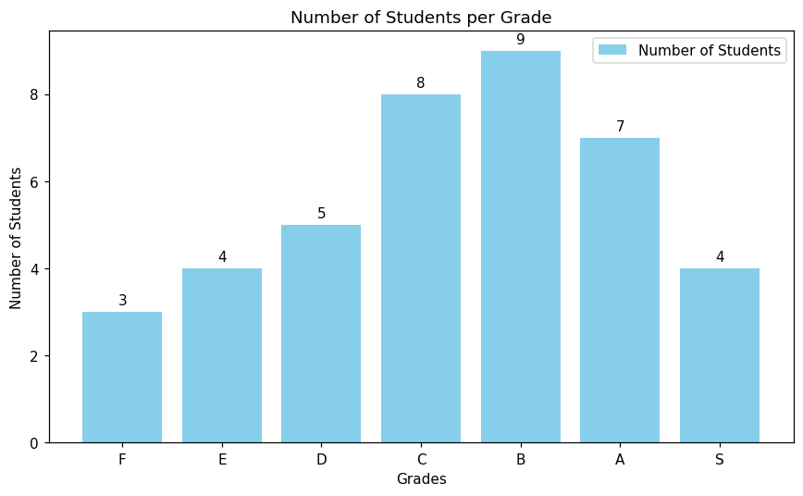
Figure 2: Bar chart – number of students per grade

Result
The pie chart and bar chart were drawn successfully. Grade B has the maximum number of students (9), grade F has the minimum (3), and 27.50% of the students secured grades A and S combined.

Question 2: Grade Analysis using a CSV File and pandas

Aim
To create a CSV file of grade-wise student counts, read and validate it with pandas, calculate percentages, generate pie and bar charts, and save both charts as image files.

Algorithm
- Start and import pandas and matplotlib.pyplot.
- Create the file student_grades.csv with the columns Grade and Number_of_Students for the grades F, E, D, C, B, A and S.
- Read the CSV file into a DataFrame using pandas.
- Validate that all seven grades are present and that the total number of students is exactly 40; otherwise raise an error.
- Calculate the percentage of students for each grade and add it as a new column.
- Display the table with the number and percentage of students per grade.
- Find and display the grades with the highest and lowest number of students.
- Draw the pie chart with percentages, title and legend, and save it as grade_pie_chart.png.
- Draw the bar chart with counts above the bars, axis labels, title and legend, and save it as grade_bar_chart.png.
- Stop.

Code
import pandas as pd
import matplotlib.pyplot as plt

FILE = "student_grades.csv"

# 1 & 2. Create CSV
pd.DataFrame({
"Grade": ["F", "E", "D", "C", "B", "A", "S"],
"Number_of_Students": [3, 4, 5, 8, 9, 7, 4],
}).to_csv(FILE, index=False)

# 3. Read CSV
df = pd.read_csv(FILE)

# 4. Validate
expected = {"F", "E", "D", "C", "B", "A", "S"}
if set(df["Grade"]) != expected or len(df) != 7:
raise ValueError("All seven grades (F, E, D, C, B, A, S) must be present.")
if df["Number_of_Students"].sum() != 40:
raise ValueError("Total number of students must be exactly 40.")
print("Validation successful.\n")

# 5. Percentage
df["Percentage"] = (df["Number_of_Students"] / 40 * 100).round(2)

# 9. Display
print(df.to_string(index=False))

# 10. Highest / lowest
hi = df.loc[df["Number_of_Students"].idxmax()]
lo = df.loc[df["Number_of_Students"].idxmin()]
print(f"\nHighest: Grade {hi['Grade']} ({hi['Number_of_Students']} students)")
print(f"Lowest : Grade {lo['Grade']} ({lo['Number_of_Students']} students)")

# 6. Pie chart
plt.figure(figsize=(7, 7))
plt.pie(df["Number_of_Students"], labels=df["Grade"], autopct="%1.1f%%", startangle=90)
plt.title("Percentage Distribution of Students by Grade")
plt.legend(df["Grade"], title="Grades", loc="center left", bbox_to_anchor=(1, 0.5))
plt.tight_layout()
plt.savefig("grade_pie_chart.png", dpi=150)
plt.show()

# 7. Bar chart
plt.figure(figsize=(8, 5))
bars = plt.bar(df["Grade"], df["Number_of_Students"], color="orange",
label="Number of Students")
for b in bars:
plt.text(b.get_x() + b.get_width() / 2, b.get_height() + 0.1,
int(b.get_height()), ha="center", va="bottom")
plt.xlabel("Grades")
plt.ylabel("Number of Students")
plt.title("Number of Students per Grade")
plt.legend()
plt.tight_layout()
plt.savefig("grade_bar_chart.png", dpi=150)
plt.show()

# 11. Saved as grade_pie_chart.png and grade_bar_chart.png
print("\nCharts saved: grade_pie_chart.png, grade_bar_chart.png")

Output
Text output
Validation successful.

Grade Number_of_Students Percentage
F 3 7.5
E 4 10.0
D 5 12.5
C 8 20.0
B 9 22.5
A 7 17.5
S 4 10.0

Highest: Grade B (9 students)
Lowest : Grade F (3 students)

Charts saved: grade_pie_chart.png, grade_bar_chart.png

Generated file: student_grades.csv
Grade,Number_of_Students
F,3
E,4
D,5
C,8
B,9
A,7
S,4

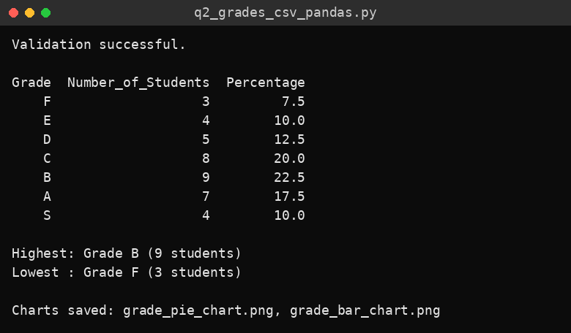
Console output
Figure 1: Pie chart saved as grade_pie_chart.png
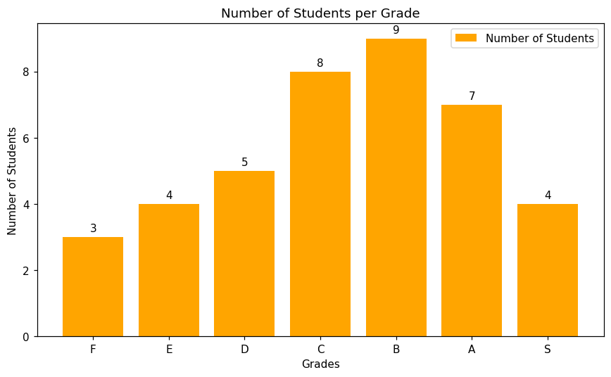
Figure 2: Bar chart saved as grade_bar_chart.png

Result
The CSV file was created, read and validated successfully. The percentage of each grade was calculated, grade B had the highest count (9) and grade F the lowest (3), and both charts were generated and saved as image files.

Question 3: Knowledge-Driven Object Identification

Aim
To identify common classroom objects (laptop, book, chair, bottle, mobile phone and table) from an image using a pretrained MobileNetV2 model together with a knowledge base and rule-based reasoning that give the object’s category, properties, description and function.

Algorithm
- Start and import tensorflow (MobileNetV2), PIL, numpy and matplotlib.
- Build a knowledge base for the six objects containing the matching ImageNet labels, properties (portable, powered, has_legs, material), description and function.
- Define the rule-based function classify() that decides the category (Portable Electronic Device, Electronic Device, Furniture, Stationery / Study Material or Household / Personal Item) from the properties.
- Load the pretrained MobileNetV2 model with ImageNet weights.
- Read the image path from the user; accept only JPG, JPEG or PNG files that exist, otherwise show an error.
- Open and display the input image.
- Resize the image to 224 × 224, preprocess it and obtain the top 10 predictions from the model.
- Add the probabilities of the predicted labels that belong to each object in the knowledge base and select the object with the highest score.
- If the score is below the 0.20 threshold, display “Object cannot be identified confidently.”
- Otherwise apply the rules and display the object name, confidence, category, properties, description and function.
- Repeat until the user enters q.
- Stop.

Code
# pip install tensorflow pillow matplotlib numpy
import os
import numpy as np
import matplotlib.pyplot as plt
from PIL import Image
from tensorflow.keras.applications.mobilenet_v2 import (
MobileNetV2, preprocess_input, decode_predictions)

# ---------------- Knowledge Base ----------------
KB = {
"laptop": {
"labels": ["laptop", "notebook", "desktop_computer", "screen", "monitor"],
"properties": {"portable": True, "powered": True, "has_legs": False, "material": "plastic/metal"},
"description": "A portable personal computer with screen and keyboard.",
"function": "Computing, browsing, programming and online learning.",
},
"book": {
"labels": ["book_jacket", "binder", "comic_book", "notebook"],
"properties": {"portable": True, "powered": False, "has_legs": False, "material": "paper"},
"description": "A set of printed pages bound together.",
"function": "Reading and studying.",
},
"chair": {
"labels": ["folding_chair", "rocking_chair", "barber_chair", "throne"],
"properties": {"portable": False, "powered": False, "has_legs": True, "material": "wood/plastic/metal"},
"description": "A piece of furniture with a back, designed for one person to sit on.",
"function": "Sitting.",
},
"bottle": {
"labels": ["water_bottle", "pop_bottle", "pill_bottle", "beer_bottle", "wine_bottle", "water_jug"],
"properties": {"portable": True, "powered": False, "has_legs": False, "material": "plastic/glass"},
"description": "A narrow-necked container used to hold liquids.",
"function": "Storing and carrying drinking water or other liquids.",
},
"mobile phone": {
"labels": ["cellular_telephone", "iPod", "hand-held_computer", "remote_control"],
"properties": {"portable": True, "powered": True, "has_legs": False, "material": "glass/metal"},
"description": "A handheld electronic communication device.",
"function": "Calling, messaging and internet access.",
},
"table": {
"labels": ["desk", "dining_table", "pool_table", "file_cabinet"],
"properties": {"portable": False, "powered": False, "has_legs": True, "material": "wood/metal"},
"description": "A piece of furniture with a flat top supported by legs.",
"function": "Holding items for working, writing or eating.",
},
}

# ---------------- Rules ----------------
def classify(p):
if p["powered"] and p["portable"]:
return "Portable Electronic Device"
if p["powered"]:
return "Electronic Device"
if p["has_legs"]:
return "Furniture"
if p["portable"] and p["material"] == "paper":
return "Stationery / Study Material"
return "Household / Personal Item"

THRESHOLD = 0.20

def identify(path):
if not path.lower().endswith((".jpg", ".jpeg", ".png")):
print("Error: only JPG, JPEG or PNG files are accepted.")
return
if not os.path.exists(path):
print("Error: file not found.")
return

img = Image.open(path).convert("RGB")
plt.imshow(img); plt.axis("off"); plt.title("Input Image"); plt.show()

x = np.expand_dims(np.array(img.resize((224, 224)), dtype="float32"), 0)
preds = model.predict(preprocess_input(x), verbose=0)
top = decode_predictions(preds, top=10)[0]

scores = {k: 0.0 for k in KB}
for _, label, prob in top:
for obj, info in KB.items():
if label in info["labels"]:
scores[obj] += float(prob)

best = max(scores, key=scores.get)
conf = scores[best]
print("Top model predictions:", [(l, round(float(p), 2)) for _, l, p in top[:3]])

if conf < THRESHOLD:
print("Object cannot be identified confidently.")
return

info = KB[best]
print("\n----- Result -----")
print("Object :", best)
print("Confidence :", f"{conf:.2%}")
print("Category :", classify(info["properties"]))
print("Properties :", info["properties"])
print("Description :", info["description"])
print("Function :", info["function"])

if __name__ == "__main__":
model = MobileNetV2(weights="imagenet")
while True:
p = input("\nEnter image path (or 'q' to quit): ").strip()
if p.lower() == "q":
break
identify(p)

Output
Run q3_object_identification.py with test images of a laptop, book, chair, bottle, mobile phone and table, and paste the screenshots of the input image and the IDLE output in the space below.
[ Paste output screenshots here ]

Test evaluation
S.No | Test image | Expected object | Identified object | Correct?
1
2
3
4
5
6

Result
The knowledge-driven system was implemented using MobileNetV2 for image recognition and a knowledge base with rules for category and function. (Add the test results from the table above after running the program on your own images.)

Question 4: Car Number Plate Recognition using OCR and an Expert System

Aim
To detect the number plate in a car image, extract the registration number using image processing and Tesseract OCR, and validate it against the Indian registration format using a knowledge base and rules that correct common OCR errors.

Algorithm
- Start and import re, os, cv2, numpy, pytesseract and matplotlib.
- Build the knowledge base: valid state codes, the registration pattern (two letters, two digits, one to three letters, four digits) and OCR character-confusion tables.
- Read the image path from the user and accept only an existing JPG, JPEG or PNG file.
- Detect the plate: convert to grayscale, apply a bilateral filter, find Canny edges and contours, and choose a four-sided contour with a plate-like aspect ratio; crop it.
- If no plate is found, display an error message.
- Preprocess the plate: grayscale, enlarge, Gaussian blur, CLAHE contrast enhancement and Otsu thresholding.
- Extract the characters using Tesseract OCR (single line, upper-case letters and digits only).
- Validate the text against the pattern and state codes; if it fails and the length is 9 to 11, correct letter/digit confusions by position and validate again.
- Display the original image, cropped plate and preprocessed plate, and print the OCR text, final registration number and validation result.
- If validation fails, display an error and allow another image to be checked; repeat until the user enters q.
- Stop.

Code
# pip install opencv-python pytesseract matplotlib numpy
# Also install the Tesseract OCR engine and, on Windows, set the path below.
import re
import os
import cv2
import numpy as np
import pytesseract
import matplotlib.pyplot as plt

# pytesseract.pytesseract.tesseract_cmd = r"C:\Program Files\Tesseract-OCR\tesseract.exe"

# ---------------- Knowledge Base (Indian registration format) ----------------
STATE_CODES = {
"AP", "AR", "AS", "BR", "CG", "CH", "DD", "DL", "DN", "GA", "GJ", "HP", "HR",
"JH", "JK", "KA", "KL", "LA", "LD", "MH", "ML", "MN", "MP", "MZ", "NL", "OD",
"PB", "PY", "RJ", "SK", "TN", "TR", "TS", "UK", "UP", "WB",
}
PATTERN = re.compile(r"^([A-Z]{2})(\d{2})([A-Z]{1,3})(\d{4})$") # e.g. TN09AB1234
TO_DIGIT = {"O": "0", "Q": "0", "D": "0", "I": "1", "L": "1", "Z": "2", "S": "5", "B": "8", "G": "6"}
TO_LETTER = {v: k for k, v in {"O": "0", "I": "1", "Z": "2", "S": "5", "B": "8", "G": "6"}.items()}

# ---------------- Image processing ----------------
def detect_plate(img):
gray = cv2.cvtColor(img, cv2.COLOR_BGR2GRAY)
gray = cv2.bilateralFilter(gray, 11, 17, 17)
edges = cv2.Canny(gray, 30, 200)
cnts, _ = cv2.findContours(edges, cv2.RETR_TREE, cv2.CHAIN_APPROX_SIMPLE)
cnts = sorted(cnts, key=cv2.contourArea, reverse=True)[:30]
for c in cnts:
approx = cv2.approxPolyDP(c, 0.018 * cv2.arcLength(c, True), True)
if len(approx) == 4:
x, y, w, h = cv2.boundingRect(approx)
if h > 0 and 2.0 <= w / h <= 6.0 and w > 80:
return img[y:y + h, x:x + w]
return None

def preprocess(plate):
g = cv2.cvtColor(plate, cv2.COLOR_BGR2GRAY)
g = cv2.resize(g, None, fx=2, fy=2, interpolation=cv2.INTER_CUBIC)
g = cv2.GaussianBlur(g, (5, 5), 0)
g = cv2.createCLAHE(clipLimit=2.0, tileGridSize=(8, 8)).apply(g)
_, th = cv2.threshold(g, 0, 255, cv2.THRESH_BINARY + cv2.THRESH_OTSU)
return th

def read_text(proc):
cfg = "--psm 7 -c tessedit_char_whitelist=ABCDEFGHIJKLMNOPQRSTUVWXYZ0123456789"
txt = pytesseract.image_to_string(proc, config=cfg)
return re.sub(r"[^A-Z0-9]", "", txt.upper())

# ---------------- Expert system rules ----------------
def validate(text):
if PATTERN.match(text) and text[:2] in STATE_CODES:
return True, text, "Valid registration format."
n = len(text)
if 9 <= n <= 11: # Rule: try positional OCR-error correction
s = n - 8 # series letters count
mask = "LLDD" + "L" * s + "DDDD"
fixed = ""
for ch, m in zip(text, mask):
if m == "L" and ch.isdigit():
ch = TO_LETTER.get(ch, ch)
elif m == "D" and ch.isalpha():
ch = TO_DIGIT.get(ch, ch)
fixed += ch
if PATTERN.match(fixed) and fixed[:2] in STATE_CODES:
return True, fixed, f"Valid after OCR correction ({text} -> {fixed})."
return False, text, "Does not satisfy registration rules."

# ---------------- Main ----------------
def process(path):
if not path.lower().endswith((".jpg", ".jpeg", ".png")) or not os.path.exists(path):
print("Error: provide an existing JPG, JPEG or PNG file.")
return
img = cv2.imread(path)
plate = detect_plate(img)
if plate is None:
print("Error: number plate could not be detected. Try another image.")
return
proc = preprocess(plate)
raw = read_text(proc)
ok, final, msg = validate(raw)

fig, ax = plt.subplots(1, 3, figsize=(14, 4))
ax[0].imshow(cv2.cvtColor(img, cv2.COLOR_BGR2RGB)); ax[0].set_title("Original Image")
ax[1].imshow(cv2.cvtColor(plate, cv2.COLOR_BGR2RGB)); ax[1].set_title("Cropped Plate")
ax[2].imshow(proc, cmap="gray"); ax[2].set_title("Preprocessed Plate")
for a in ax: a.axis("off")
plt.tight_layout(); plt.show()

print("OCR text :", raw)
print("Registration number :", final)
print("Validation result :", "VALID" if ok else "INVALID", "-", msg)
if not ok:
print("Error: text failed validation. Please check another image.")

if __name__ == "__main__":
while True:
p = input("\nEnter car image path (or 'q' to quit): ").strip()
if p.lower() == "q":
break
process(p)

Output
Text output
Enter car image path (or 'q' to quit): Q4_image.jpeg
OCR text : TNO9BY9726
Registration number : TN09BY9726
Validation result : VALID - Valid after OCR correction (TNO9BY9726 -> TN09BY9726).

Enter car image path (or 'q' to quit): q

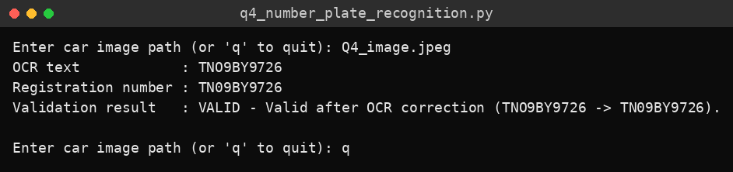
Console output
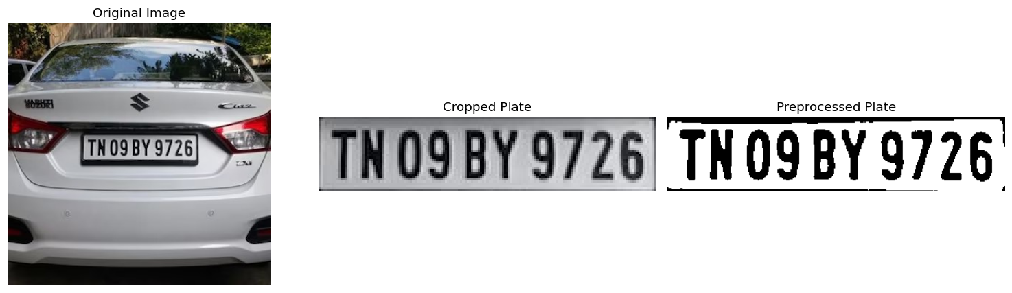
Figure 1: Original image, cropped number plate and preprocessed plate

Result
The number plate was detected and cropped, and OCR read “TNO9BY9726”. The expert system corrected the letter O to the digit 0 using the positional rules and validated the registration number TN09BY9726 as VALID.

